**DAILY ONLINE ACTIVITIES SUMMARY**

|  |  |  |  |  |  |  |  |  |
| --- | --- | --- | --- | --- | --- | --- | --- | --- |
| **Date:** | **18/05/2020** | | | | | **Name:** | **Lavanya D M** | |
| **Sem & Sec** | **4th & ‘A’** | | | | | **USN:** | **4al18cs041** | |
| **Online Test Summary** | | | | | | | | |
| **Subject** | | **Maths** | | | | | | |
| **Max. Marks** | | **30** | | **Score** | | | **Not yet decleared** | |
| **Certification Course Summary** | | | | | | | | |
| **Course** | **HTML and CSS** | | | | | | | |
| **Certificate Provider** | | | **Bitdegree** | | **Duration** | | | **2WEEK** |
| **Coding Challenges** | | | | | | | | |
| **Problem Statement:Finding the frequency of “HELLO FRIEND”** | | | | | | | | |
| **Status:complied** | | | | | | | | |
| **Uploaded the report in Github** | | | | | **Yes** | | | |
| **If yes Repository name** | | | | | <https://github.com/lavanyamurthi/lockdown-coding/blob/master/18may> | | | |
| **Uploaded the report in slack** | | | | | **Yes** | | | |

Online Test Details: (Attach the snapshot and briefly write the report for the same)

Certification Course Details: (Attach the snapshot and briefly write the report for the same)

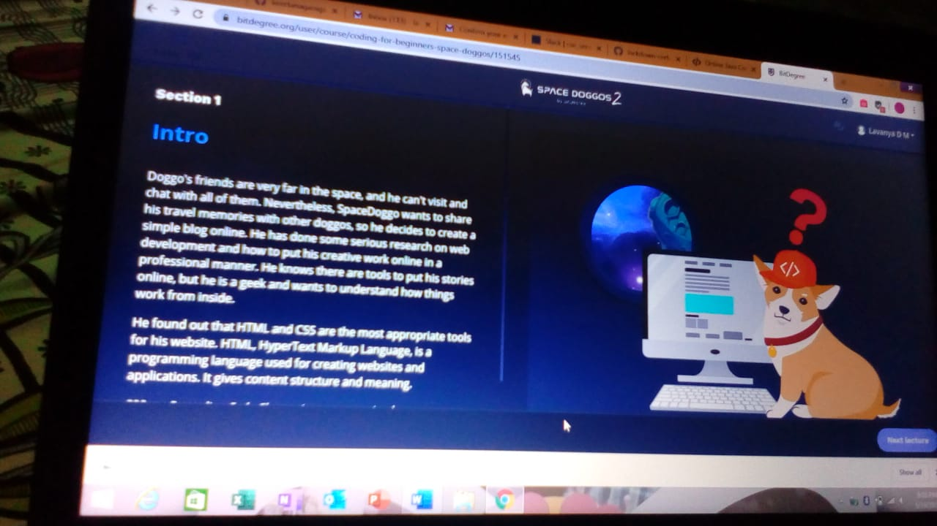

I had started the html and css online certificate course from bitdegree

Coding Challenges Details: (Attach the snapshot and briefly write the report for the same)

This is the snapshot of the output of the program which had uploaded in github

